Software Requirements Specification – Group 4
Project Title – RehabEdge: Remote Physical Therapy with Edge AI
WIKI LINK : https://github.com/Sidduri2025/RehabEdge/wiki/Software-Requirements-Specification-%E2%80%93-Group-4
Functional Requirements WIKI LINK: https://github.com/Sidduri2025/RehabEdge/wiki/Functional-Requirements-List-%E2%80%90-Final-%E2%80%90-Group-4

About the Developers:
Name: Vaishnavi Sidduri
UserName: Sidduri2025
GitHub: Sidduri2025
Strengths & Interests: Python, Web Development, Databases

Name: Chaithanya Reddy Pailla
UserName: chaithanyareddypailla
GitHub: chaithanyareddypailla
Strengths & Interests: Machine learning, SQL, Python

Name: Jhansi Akshara Sanagala
UserName: Akshara266
GitHub: Akshara266
Strengths & Interests: Java, Web application, Springboot

Name: Praneetha Reddy Lakkam
UserName: praneetha2908
GitHub: praneetha2908
Strengths & Interests: Python, Data Structures, Machine Learning

Project Charter:
Summary of the Problem
When patients do physical therapy at home, it’s easy to miss sessions or do exercises with the wrong posture since no one is watching.
This slows down recovery. At the same time, doctors don’t have a simple way to track how patients are doing between visits.
Motivation for Solving the Problem
This project aims to improve the client’s workflow by providing an AI-powered mobile and web platform that guides patients through therapy exercises using camera-based posture detection.
The solution ensures:
- Patients stay consistent with therapy through reminders and feedback.
- Doctors gain valuable insights into patient performance and recovery trends.
- Overall efficiency of therapy management is improved, reducing the need for frequent in-person visits.
Required Functionality
Patient Mobile App
- Daily reminders for scheduled exercises
- Real-time feedback on posture using edge AI and device cameras
- Exercise logs for tracking progress
Doctor Web Dashboard
- Access to each patient’s exercise history
- Weekly and monthly trend visualization of recovery progress
- Ability to track adherence and spot potential issues early
Additional Features (Future Scope)
- Secure patient–doctor communication
- Cloud sync with electronic health records (EHR)

Problem Statement:
Overview:
- The RehabEdge application is a web and mobile based platform designed to support patients in performing their prescribed physical therapy exercises effectively at home. Many patients struggle to maintain correct posture, remember exercise routines, or stay consistent between clinic visits.
- RehabEdge addresses these challenges through the integration of edge-based AI technology, which uses the device’s camera to analyze patient movements in real time and provide posture correction feedback.
Problem statement:
- Patients undergoing physical therapy are often required to perform exercises independently at home between clinic visits. However, most patients forget their routines, misplace written instructions, or misunderstand verbal directions. Generic videos or handouts fail to ensure correct posture and consistent adherence.
- As a result, patients frequently miss therapy sessions, perform exercises incorrectly, or stop when discomfort occurs. The lack of real-time feedback leads to slow recovery and possible re-injury.
- From the doctor’s perspective, progress data relies on patient self-reporting, which is often incomplete or inaccurate. Without reliable insight into home performance, doctors cannot effectively track patient adherence, posture, or progress, making it difficult to adjust treatment plans efficiently.

Design:
USE CASES:
- The system SHALL allow patients to create

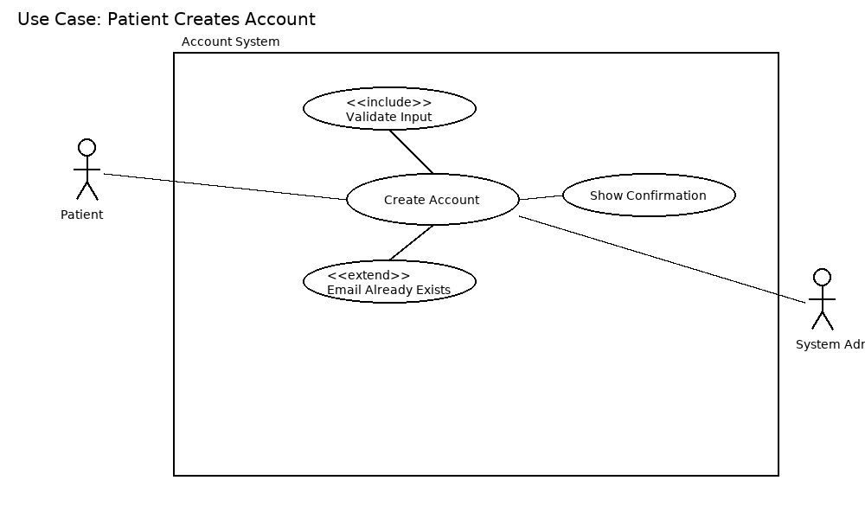
Use Case : Patient Creates Account
Actor : Patient
Scope: Account Management System
Brief: Patient registers a new account by providing required details.
Stakeholders: Patient, System Administrator (ensures system availability).
Preconditions: Patient does not already have an existing account.
Postconditions: A new patient account is successfully created.
Trigger: Patient selects "Create Account."
Basic Flow:
  - Patient selects "Create Account."
  - System prompts for personal details (name, email, password).
  - Patient enters details and submits.
  - System validates input.
  - System creates a new patient account.
  - Confirmation message is displayed.
Extensions:
  - 3a. Invalid or missing details → system shows error and requests correction.
  - 4a. Email already exists → system rejects and suggests login.

- The system SHALL allow patients to update their personal account details.

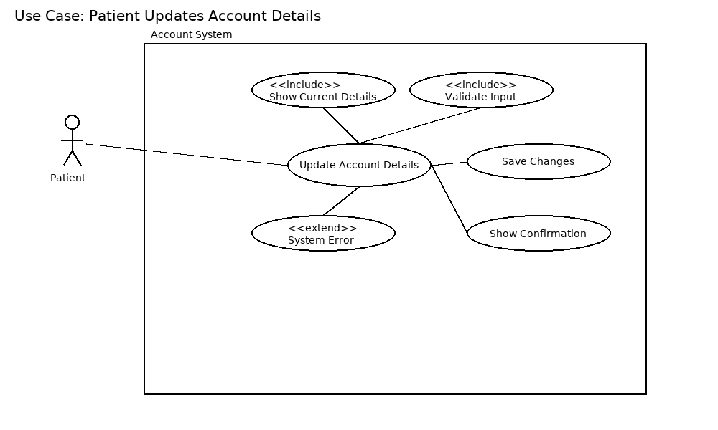
Use Case : Patient Updates Account Details
Actors: Patient
Scope: Account Management System
Brief: Patient modifies personal details like email, phone, or address.
Stakeholders: Patient, System Administrator.
Preconditions: Patient is logged in.
Postconditions: Updated account details are saved.
Trigger: Patient chooses "Update Account Details."
Basic Flow:
    - Patient logs in.
    - Patient selects "Update Account."
    - System displays current details.
    - Patient edits details.
    - System validates input.
    - System saves updated details.
    - Confirmation is shown.
Extensions:
- 5a. Invalid details entered → system prompts correction.
- 6a. System error → update not saved, error shown.
- The system SHALL allow patients to change their account password.

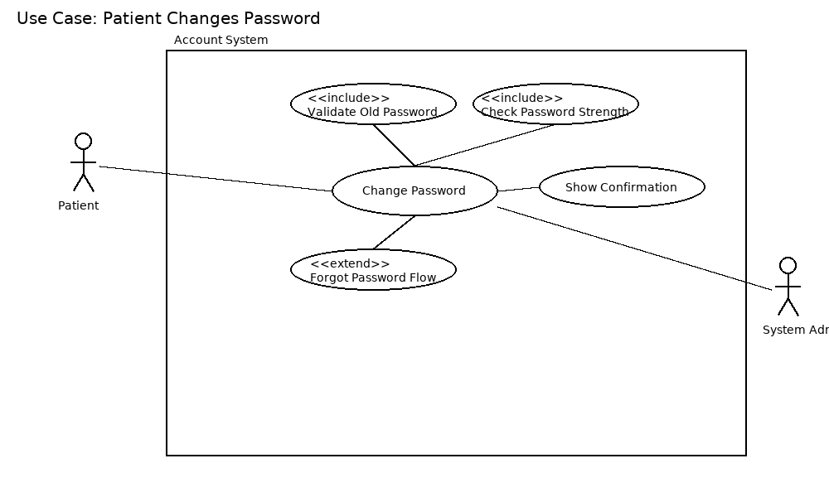
Use Case 3: Patient Changes Password
Actors: Patient
Scope: Account Management System
Brief: Patient updates their account password securely.
Stakeholders: Patient, System Administrator.
Preconditions: Patient is logged in and remembers the old password.
Postconditions: Password is updated successfully.
Trigger: Patient selects "Change Password."
Basic Flow:
  - Patient logs in.
  - Patient selects "Change Password."
  - System prompts for old and new password.
  - Patient enters required details.
  - System validates old password and new password rules.
  - System updates password.
  - Confirmation displayed.
Extensions:
  - 4a. Old password incorrect → system rejects request.
  - 5a. New password weak → system requests stronger password.

- The system SHALL allow patients to securely delete their account.

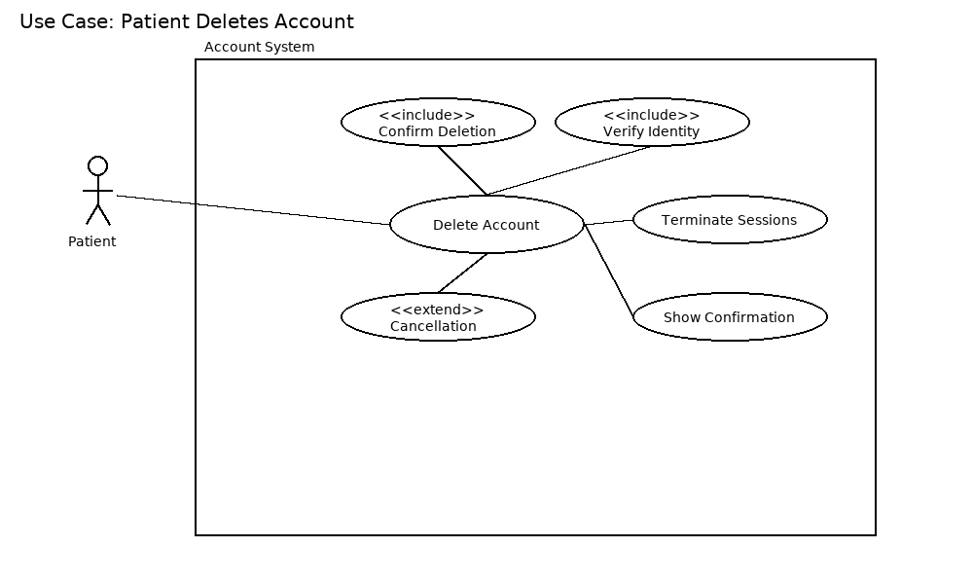
Use Case 4: Patient Deletes Account
Actors: Patient
Scope: Account Management System
Brief: Patient securely deletes their account.
Stakeholders: Patient, System Administrator.
Preconditions: Patient is logged in.
Postconditions: Account and related data are permanently removed.
Trigger: Patient selects "Delete Account."
Basic Flow:
  - Patient logs in.
  - Patient selects "Delete Account."
  - System asks for confirmation.
  - Patient confirms.
  - System deletes account data.
  - Confirmation shown and session ends.
Extensions:
  - 3a. Patient cancels → deletion aborted.
  - 5a. System error → account not deleted, error shown.

- The system SHALL allow doctors to create accounts.

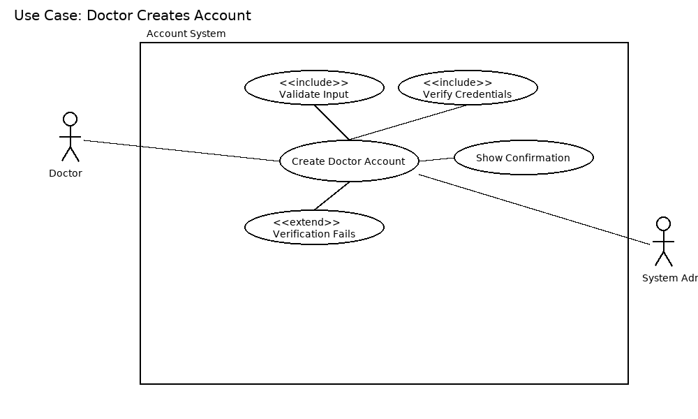
Use Case 5: Doctor Creates Account
Actors: Doctor
Scope: Account Management System
Brief: Doctor registers a new account by providing required details.
Stakeholders: Doctor, System Administrator.
Preconditions: Doctor does not already have an existing account.
Postconditions: A new doctor account is successfully created.
Trigger: Doctor selects "Create Account."
Basic Flow:
  - Doctor selects "Create Account."
  - System prompts for professional and personal details.
  - Doctor enters details and submits.
  - System validates input and verifies doctor credentials (if required).
  - System creates doctor account.
  - Confirmation displayed.
Extensions:
  - 3a. Invalid or missing details → system shows error.
  - 4a. Verification fails → account not created.
- The system SHALL authenticate user credentials using encryption.
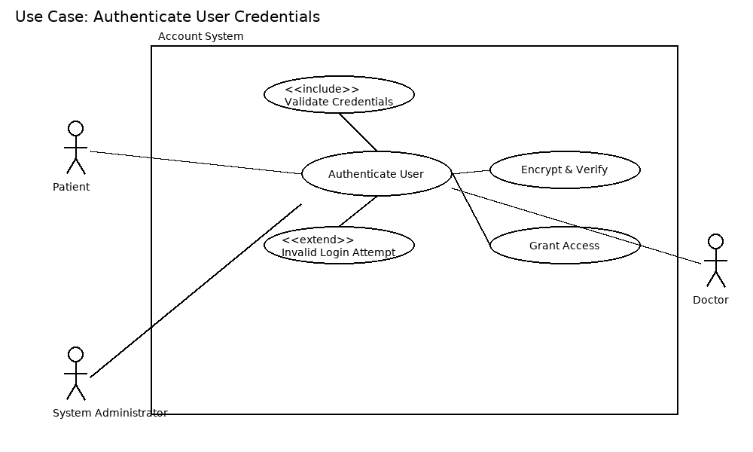
Use Case 6: Authenticate User Credentials
Actors: Patient, Doctor, Admin
Scope: Healthcare Management System
Brief: Validates user login using encrypted credentials.
Stakeholders: All users, Security Admin
Preconditions: User has an account.
Postconditions: User logged in or rejected.
Trigger: User enters login credentials.
Basic Flow:
- User enters username and password.
- System encrypts password and compares with stored hash.
- If matched → access granted.
Extensions:
- 3a. Invalid login → error message shown.
- 3b. Multiple failed attempts → account locked.
- The system SHALL send daily reminders to patients for scheduled therapy exercises.
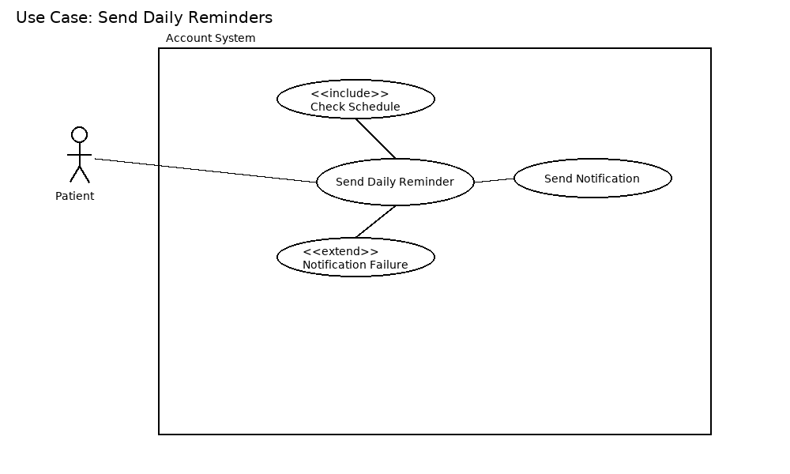
Use Case 7: Send Daily Reminders
Actors: Patient
Scope: Healthcare Management System
Brief: System sends daily exercise reminders to patients.
Stakeholders: Patients, Doctors
Preconditions: Patient has active therapy schedule.
Postconditions: Patient receives reminder notification.
Trigger: Daily scheduler triggers reminder.
Basic Flow:
- Scheduler checks patient’s therapy plan.
- System prepares reminder message.
- System sends via email/SMS/app notification.
Extensions:
- 3a. Network issue → reminder queued for retry.
- The system SHALL use the device camera to capture patient exercise sessions.
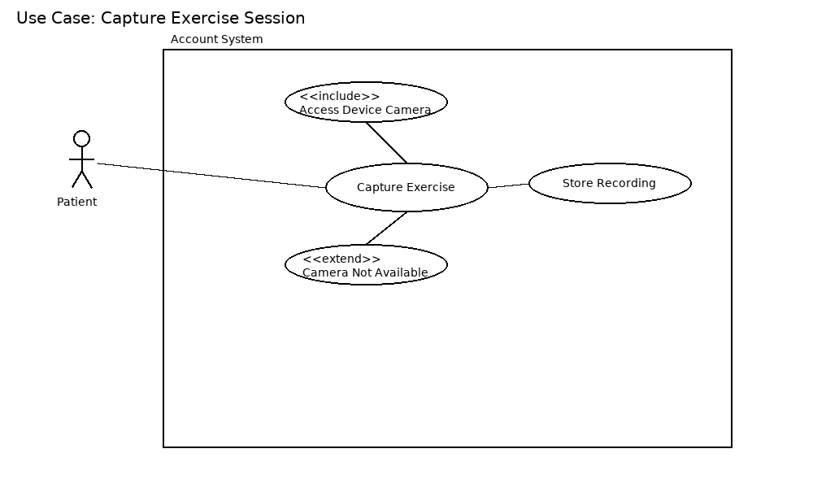
Use Case 8: Capture Exercise Session
Actors: Patient
Scope: Healthcare Management System
Brief: System uses device camera to capture exercise sessions.
Stakeholders: Patients, Doctors, Therapists
Preconditions: Patient has camera-enabled device.
Postconditions: Session video stored securely.
Trigger: Patient starts exercise session.
Basic Flow:
- Patient launches exercise capture.
- System requests camera access.
- Patient performs exercises.
- Session recorded and stored.
Extensions:
- 2a. Camera not available → error displayed.
- 4a. Storage full → recording stopped with warning.

- The system SHALL store exercise history for each patient.
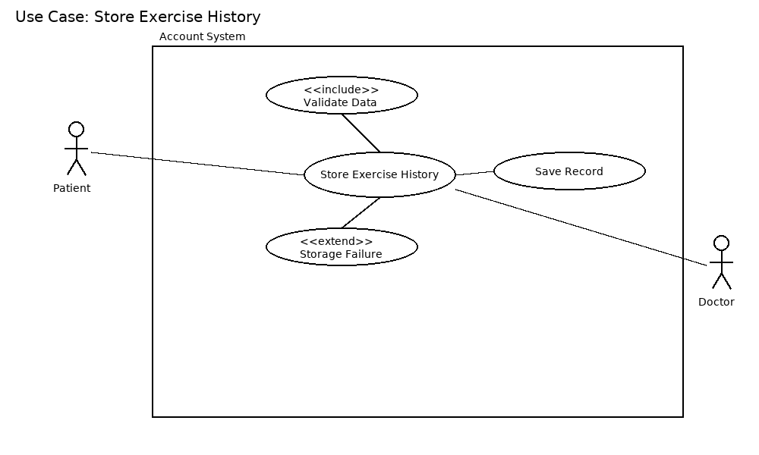
Use Case 9: Store Exercise History
Actors: Patient, Doctor
Scope: Healthcare Management System
Brief: Saves patients’ exercise activity history.
Stakeholders: Patients, Doctors
Preconditions: Patient performed exercises.
Postconditions: Exercise history stored in database.
Trigger: End of exercise session.
Basic Flow:
- System collects exercise data.
- Validates data.
- Stores into patient’s history log.
- Confirms storage success.
Extensions:
- 2a. Data invalid → system discards.
- 3a. Database unavailable → retry queued.

- The system SHALL provide doctors with a dashboard to view weekly progress and adherence.
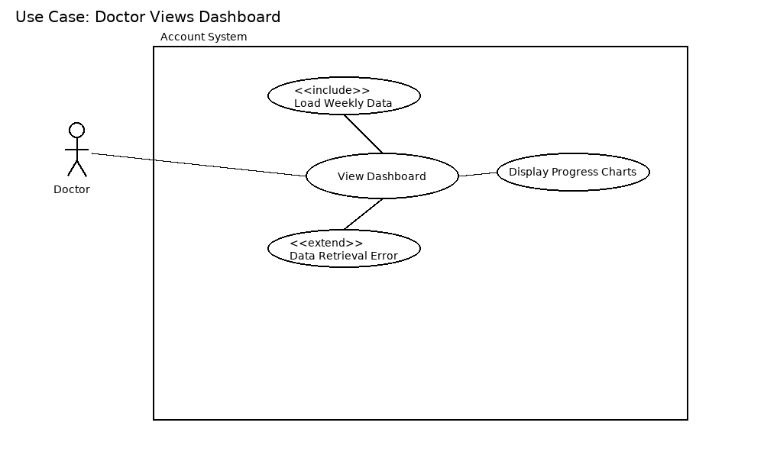

Use Case 10: Doctor Views Dashboard
Actors: Doctor
Scope: Healthcare Management System
Brief: Doctor reviews patient progress via dashboard.
Stakeholders: Doctors, Patients
Preconditions: Patients have recorded exercise history.
Postconditions: Weekly progress charts displayed.
Trigger: Doctor selects “Dashboard”.
Basic Flow:
- Doctor opens dashboard.
- System retrieves weekly exercise data.
- System generates charts/tables.
- Doctor reviews adherence and progress.
Extensions:
- 2a. Data retrieval error → error shown.
- 3a. No patient history → message displayed.

11.The system SHALL notify doctors when a patient misses multiple therapy sessions.

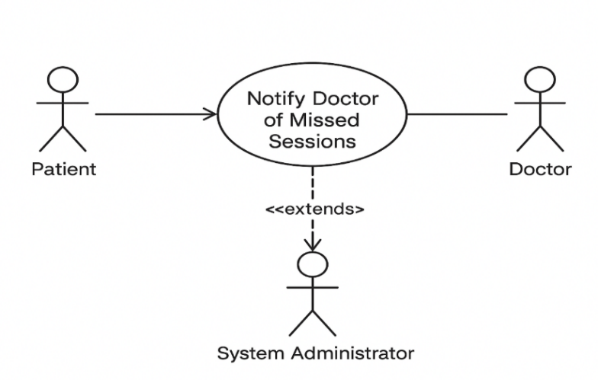

Use Case: Notify Doctor of Missed Sessions
Actor: System (primary), Doctor (secondary)
Scope: RehabEdge – Remote Physical Therapy
Brief: The system automatically tracks patient exercise sessions. If a patient misses multiple therapy sessions, the system notifies the doctor so appropriate action can be taken.
Stakeholders: Patient, Doctor, System Administrator
Preconditions:
- Patient is registered and has assigned sessions.
- System is actively tracking attendance.
Postconditions:
- Notification sent to Doctor.
- Patient record updated with missed session details.
Triggers:
- Patient misses multiple scheduled therapy sessions.
Basic Flow:
- System monitors patient session attendance.
- Patient misses more than the allowed number of sessions.
- System automatically generates a notification.
- Notification is sent to the Doctor.
- Doctor reviews patient status and may take necessary action.
Extensions (Alternate Flows):
- 2a. Grace Period: If the patient has a valid excuse (pre-approved leave), the system does not notify the doctor.
- 2b. System Error: If tracking fails due to technical error, the system alerts the administrator instead of the doctor.

12.The system SHALL NOT store passwords in plain text.

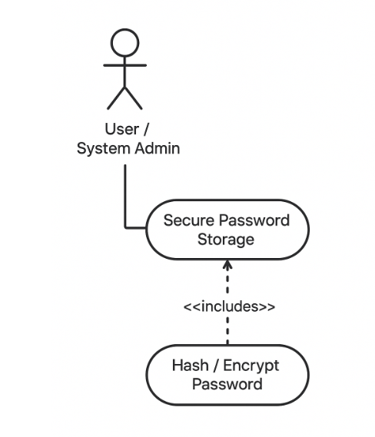
Use Case Name: Secure Password Storage
Actor(s): System, System Administrator
Scope: Application Security
Brief: The system must ensure that user passwords are stored securely using hashing and/or encryption, so that plain text passwords are never stored.
Stakeholders:
- System Administrator: Ensures security compliance.
- Users: Their passwords are protected from unauthorized access.
Preconditions:
- User account exists.
- Password is being created or updated.
Postconditions:
- Password stored securely in hashed/encrypted form.
- Plain text password is never retrievable.
Triggers:
- User creates a new account.
- User updates their password.
Basic Flow:
- User/System Administrator submits a new password.
- System hashes/encrypts the password using secure algorithms (e.g., bcrypt, SHA-256 with salt).
- System stores only the hashed/encrypted password in the database.
- User can authenticate later using the stored hashed password.
Exceptions / Alternative Flows:
- If hashing/encryption fails, an error is logged and the password is not stored.
13.The system SHALL generate visual progress reports for both patients and doctors.
Use Case Specification
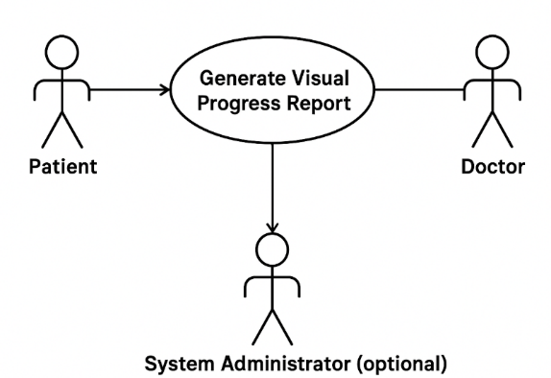
Use Case Name: Generate Visual Progress Report
Actors:
- Patient
- Doctor
- System Administrator (optional, for managing/report access)
Scope: RehabEdge – Remote Physical Therapy
Brief Description:
The system automatically generates visual progress reports (charts, graphs, summaries) to show a patient’s therapy performance over time. Both patients and doctors can view these reports to track improvement.
Preconditions:
- Patient has an account and therapy sessions recorded.
- Doctor has access to assigned patients.
- System is operational and has stored session data.
Postconditions:
- Visual report is generated and available for viewing.
- Reports may be downloadable or printable.

Triggers:
- Patient or doctor requests a report.
- Scheduled automatic report generation (optional).
Basic Flow:
- Actor (Patient or Doctor) selects the “Generate Progress Report” option.
- System retrieves relevant session and performance data.
- System generates visual report (charts, graphs, summaries).
- System displays report to the actor.
- Actor may download or print the report.

14. The system SHOULD generate a weekly summary of patient progress.
Use Case Description
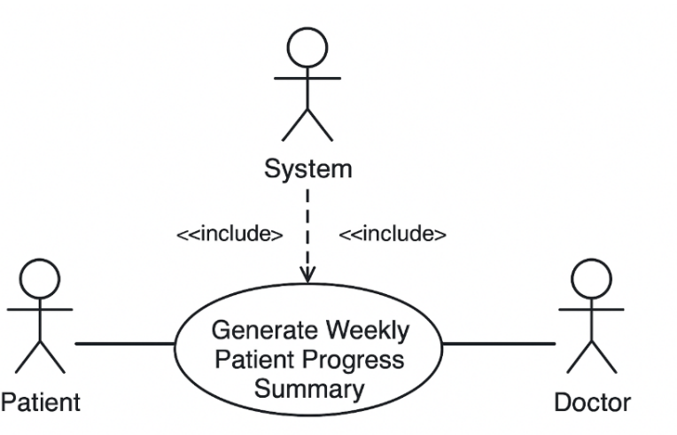
Use Case Name: Generate Weekly Patient Progress Summary
Actor(s):
- Patient – Receives the summary (optional if summary is only for doctors)
- Doctor – Views the summary for monitoring patient progress
- System Administrator – Ensures system generates summaries correctly
Scope: RehabEdge – Remote Physical Therapy System
Brief Description:
The system automatically collects data from patients’ exercise sessions and generates a summary report at the end of each week. This summary includes the number of sessions completed, improvements in performance, and areas needing attention. The report is made available to both the patient and the doctor.
Stakeholders:
- Patient (wants to track progress)
- Doctor (wants to monitor patient improvement)
- System Administrator (wants system functionality to work correctly)
Preconditions:
- Patient is registered and has completed sessions during the week
- Exercise data has been recorded accurately

Postconditions:
- Weekly summary report is generated and stored in the system
- Notifications may be sent to the patient and doctor that the report is available
Triggers:
- End of the week or doctor/patient request for the weekly summary
Basic Flow:
- System collects exercise data for the patient during the week.
- System analyzes performance metrics and progress.
- System generates a summary report.
- Report is stored in the system.
- Notification is sent to patient and/or doctor that the summary is available.
Alternative Flows:
- If data is missing for some sessions, the report indicates incomplete data.

15. The system SHOULD allow doctors to view historical exercise data for a patient
Use Case Description
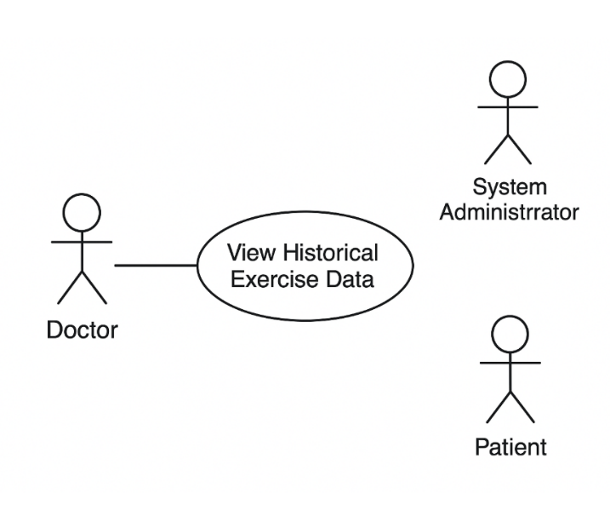

Use Case Name: View Historical Exercise Data
Actor(s):
- Doctor – main actor who views the data
- Patient – source of the exercise data
- System Administrator – ensures system functions properly
Scope: RehabEdge – Remote Physical Therapy
Brief Description:
The doctor can access a patient’s historical exercise data, including completed sessions, performance trends, and missed activities. This helps in assessing progress and adjusting treatment plans.
Stakeholders:
- Doctor (wants to monitor and analyze patient’s past performance)
- Patient (wants accurate history to be available)
- System Administrator (wants reliable functionality)

Preconditions:
- Doctor is logged into the system
- Patient profile exists with stored exercise data
Postconditions:
- Historical exercise data is retrieved and displayed to the doctor
Triggers:
- Doctor selects a patient’s profile and requests historical data
Basic Flow:
- Doctor logs into the system.
- Doctor searches for a specific patient.
- System retrieves stored exercise history.
- Doctor views the historical exercise data in a readable format (charts, tables, summaries).
Alternative Flow:
- If no historical data exists, the system displays a “No Data Available” message.

16. The system SHOULD allow Doctors to set personalized exercise plans per patient.
Use Case 16: Assign Personalized Exercise Plan
Actors:
Doctor (primary), Patient (secondary), System Administrator (support)
Scope:
RehabEdge – Remote Physical Therapy
Brief Description:
Doctor creates or updates an individualized exercise plan for a patient based on their medical condition and therapy goals.
Stakeholders:
Doctor – wants to design appropriate therapy plans
Patient – wants to receive personalized care
System Administrator – ensures system works properly
Preconditions:
Doctor is logged into the system
Patient profile exists
Postconditions:
Exercise plan is saved in the system and visible to patient
Notifications sent to patient
Triggers:
Doctor selects a patient to assign a new exercise plan
Basic Flow:
- Doctor logs into system
- Doctor selects a patient profile
- Doctor creates/updates an exercise plan (type, reps, schedule)
- System validates inputs and saves plan
- Notification sent to patient
Extensions / Alternative Flows:
- 3a: Patient profile incomplete → System requests missing details
- 4a: Schedule conflict detected → Suggests alternative times
Use Case Diagram:
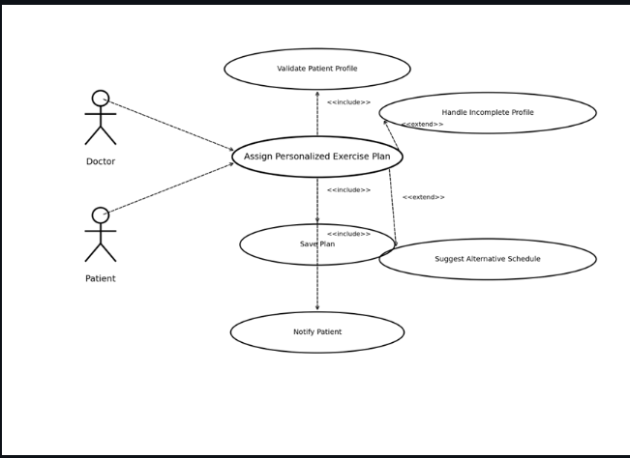
17.The system SHOULD notify patients about upcoming virtual appointments.
Use Case 17: Notify Patients of Virtual Appointments
Actors:
System (primary), Patient (secondary), Doctor (reference actor)
Scope:
RehabEdge – Remote Physical Therapy
Brief Description:
System automatically reminds patients of upcoming scheduled virtual appointments via notifications.
Stakeholders:
Patient – wants timely reminders
Doctor – expects patient attendance
System Administrator – ensures notification system works
Preconditions:
Appointment scheduled in system
Patient has valid contact details
Postconditions:
Notification sent to patient
Patient can confirm or reschedule
Triggers:
Appointment time approaches (e.g., 24 hours or 1 hour before)
Basic Flow:
- System checks upcoming appointments
- System generates reminder message
- Notification delivered to patient
- Patient acknowledges reminder
Extensions / Alternative Flows:
- 3a: Invalid contact details → Notification fails, system logs error
- 4a: Patient chooses to reschedule → Appointment updated
Use Case Diagram:
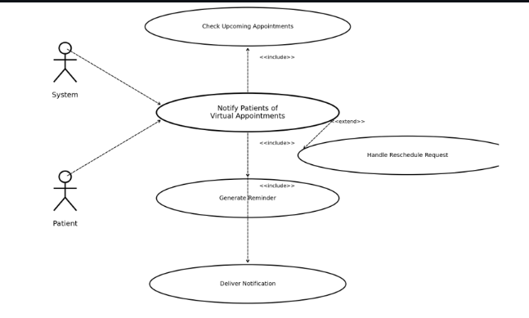
18. The system MAY allow patients to schedule virtual appointments with doctors.
Use Case 18: Patient Schedules Virtual Appointment
Actors:
Patient (primary), Doctor (secondary), System Administrator
Scope:
RehabEdge – Remote Physical Therapy
Brief Description:
Patients can request and schedule virtual appointments with available doctors.
Stakeholders:
Patient – wants to book appointments easily
Doctor – wants to manage schedule effectively
System Administrator – ensures calendar availability works
Preconditions:
Patient is logged in
Doctor availability is published
Postconditions:
Appointment booked and saved in system
Notifications sent to doctor and patient
Triggers:
Patient selects 'Schedule Appointment' option
Basic Flow:
- Patient logs into system
- Patient selects 'Schedule Appointment'
- System displays available doctor slots
- Patient selects preferred slot
- System confirms booking and sends notifications
Extensions / Alternative Flows:
- 3a: No slots available → System suggests alternatives
- 5a: Doctor rejects request → Patient notified with reschedule option
Use Case Diagram:
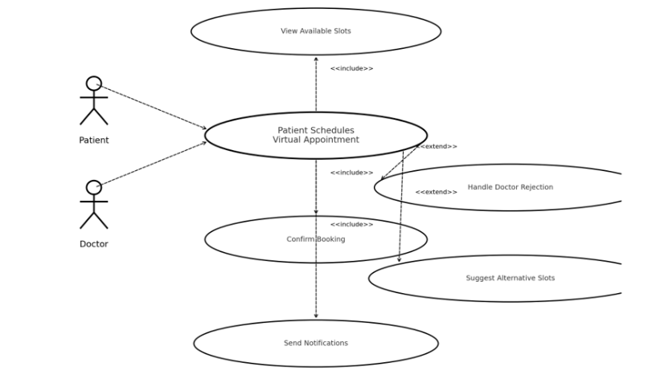
19 . The system MAY allow patients to manually log completed exercises.
Use Case 19: Patient Logs Completed Exercises
Actors:
Patient (primary), System Administrator (secondary)
Scope:
RehabEdge – Remote Physical Therapy
Brief Description:
Patient records their exercise completion manually in the system.
Stakeholders:
Patient – wants to track daily exercise
Doctor – uses logs for monitoring progress
System Administrator – ensures data is recorded properly
Preconditions:
Patient is logged in
Exercise plan assigned
Postconditions:
Exercise completion recorded in patient history
Triggers:
Patient selects 'Log Exercise' option
Basic Flow:
- Patient logs into system
- Patient selects assigned exercise
- Patient enters completion details (sets, reps, date/time)
- System validates and saves entry
- Updated progress shown in dashboard
Extensions / Alternative Flows:
- 3a: Patient enters invalid data → System prompts correction
- 4a: System error → Exercise not saved, error displayed
Use Case Diagram:

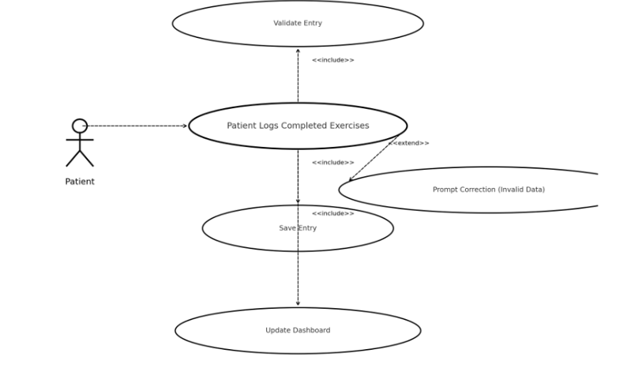
20 The system MAY allow patients to share progress reports with caregivers or family members.
Use Case 20: Share Progress Report
Actors:
Patient (primary), Caregiver/Family Member (secondary), System Administrator (support)
Scope:
RehabEdge – Remote Physical Therapy
Brief Description:
Patient can share progress reports (weekly/monthly summaries) with caregivers or family members.
Stakeholders:
Patient – wants family support
Caregiver/Family – wants to monitor patient progress
Doctor – ensures reports are consistent with treatment
Preconditions:
Patient has generated progress report
Patient is logged in
Postconditions:
Report shared with selected caregiver(s)
Triggers:
Patient selects 'Share Report' option
Basic Flow:
- Patient logs into system
- Patient selects 'Share Progress Report'
- Patient enters caregiver email/contact
- System shares report securely (link/email)
- Caregiver receives report notification
Extensions / Alternative Flows:
- 3a: Invalid contact info → System shows error
- 4a: Permission revoked → Report access disabled
Use Case Diagram:
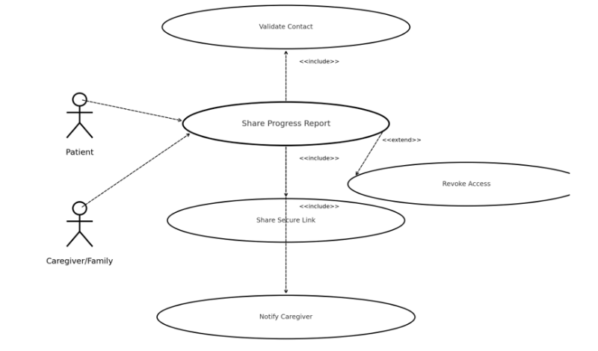

Functional Requirements List:
Mandatory Requirements (System SHALL)
1.The system SHALL allow patients to create accounts.
2.The system SHALL allow patients to update their personal account details.
3.The system SHALL allow patients to change their account password.
4.The system SHALL allow patients to securely delete their account.
5.The system SHALL allow doctors to create accounts.
6.The system SHALL authenticate user credentials using encryption.
7.The system SHALL send daily reminders to patients for scheduled therapy exercises.
8. The system SHALL capture exercise sessions using the device camera and analyze patient posture using Edge AI posture-detection models.
9.The system SHALL store exercise history for each patient (based on session date, duration, posture scores, number of exercises completed and weekly progress trends).
10. The system SHALL provide doctors with a dashboard displaying weekly progress and adherence, including posture accuracy scores derived from AI posture-detection results.
11. The system SHALL notify doctors when a patient misses more than two therapy sessions.
12.The system SHALL NOT store passwords in plain text.
13.The system SHALL generate visual progress reports for both patients and doctors.
Recommended Requirements (System SHOULD)
14.The system SHOULD generate a weekly summary of patient progress.
15.The system SHOULD allow doctors to view historical exercise data for a patient.
16.The system SHOULD allow Doctors to set personalized exercise plans per patient.
17.The system SHOULD notify patients about upcoming virtual appointments.
18. The system SHOULD support Android devices running version 10 and above.
19. The web dashboard SHOULD support modern browsers (Chrome, Edge, Firefox).
Optional Requirements (System MAY)
20.The system MAY allow patients to schedule virtual appointments with doctors.
21.The system MAY allow patients to share progress reports with caregivers or family members.
Non-functional requirements:
1. Performance
- The RehabEdge AI module should analyze posture and give corrective feedback within 1 second of detecting an incorrect movement.
- The mobile app should launch within 3 seconds on standard Android devices (Android 10 or later)
- Daily reminders must be delivered with 99% reliability at the scheduled time.
2. Security
- All posture and video data must be encrypted using AES-256 before transmission to the app or server
- User authentication must require a strong password (minimum 8 characters, alphanumeric with one symbol).
- Data transfer between app and cloud should use HTTPS (TLS 1.2 or higher) to ensure secure communication.
3. Stability & Reliability
- If the internet connection is lost, the RehabEdge app must continue operating offline and automatically sync results within 10 minutes of reconnection.
- The system should recover from crashes or interruptions in under 5 seconds without losing session data.
- Reminder notifications must succeed 99% of the time
4. Availability
- The doctor dashboard should maintain 99.5% uptime monthly to ensure continuous access.
- Patients should always be able to record and save exercises locally even when the server is temporarily down.
5. Usability
- The mobile interface should support font sizes ≥ 16sp for readability by elderly patients.
- Buttons should have a minimum touch area of 48dp × 48dp as per Android accessibility standards.
6. Scalability
- The platform should support up to 1,000 concurrent users.
- The system should be able to auto-scale cloud instances during peak usage
7. Maintainability
- The AI posture detection model should be updateable via over-the-air (OTA) updates without reinstalling the entire app.
- Code changes should be deployed and tested using a Git-based CI/CD workflow.
8. Privacy & Compliance
- Only authorized and authenticated doctors can access patient progress or health data
- Patients must have full control of their data, including options to download or delete it permanently.

Data management plan:
Summary of Data to Be Stored
1. User Credentials Information
• User ID: A unique identifier for every registered user.
• Email: The login email address used for authentication.
• Password: Stored securely using AES-256 encryption with salted hashing.
• Role: Defines user category (Doctor / Patient / Admin).
• Purpose: Stores all login and authentication-related data for secure system access.
2. Doctor Information
• Doctor ID: A unique identifier for each doctor.
• Name: Full name of the doctor.
• Specialization: Area of expertise (e.g., Orthopedic, Neurology).
• Experience: Years of professional medical practice.
• Availability: Weekly time slots available for consultation.
• User ID (FK): References the UserCredentials table to authenticate login.
• Purpose: Stores doctor-specific profile and scheduling details linked with login credentials.
3. Patient Information
• Patient ID: Unique identifier for each patient.
• Name: Full name of the patient.
• Date of Birth: Used for therapy customization.
• Contact: Phone number or communication preference.
• Assigned Doctor ID (FK): References the supervising doctor.
• Reminder Preference: Frequency of exercise reminders.
• User ID (FK): Links to the UserCredentials table for authentication.
• Purpose: Maintains personal, medical, and communication details of patients.
4. Exercise Details
• Exercise ID: Unique identifier for each exercise.
• Name: Title of the exercise.
• Description: Brief explanation of purpose and method.
• Target Body Part: Body area focused on during exercise.
• Difficulty Level: Categorized as Easy / Moderate / Hard.
• AI Model Reference: Edge AI posture detection model associated with exercise.
• Purpose: Defines the exercise catalog and AI references used during sessions.
5. Session Data
• Session ID: Unique session identifier.
• Patient ID (FK): Patient performing the session.
• Doctor ID (FK): Doctor overseeing the session.
• Exercise ID (FK): Exercise performed during the session.
• Date & Time: When the session occurred.
• Duration: Session length in minutes.
• Accuracy Score: Posture accuracy calculated by AI.
• Feedback Notes: Observations from doctor or AI.
• Video Link: Optional URL to recorded session video.
• Purpose: Records each exercise session with complete AI analytics and supervision metadata.
6. Notification Details
• Notification ID: Unique identifier for each alert or reminder.
• Patient ID (FK): Patient receiving the notification.
• Message: Notification content.
• Type: Delivery mode (Mobile, Email, SMS).
• Status: Sent / Pending / Failed.
• Scheduled Time: When notification is to be triggered.
• Purpose: Stores automated reminder information for exercises, appointments, or missed sessions.
7. Reports Information
• Report ID: Unique identifier for each progress report.
• Patient ID (FK): Patient to whom the report belongs.
• Doctor ID (FK): Doctor who validated the report.
• Generated Date: Date report was created.
• Summary Text: Overview of progress summary.
• Accuracy Trend: Aggregated posture accuracy from sessions.
• Adherence Score: Percentage of exercises completed as prescribed.
• Report Link: Link to downloadable PDF or dashboard visualization.
• Purpose: Generates analytical data for weekly or monthly performance reports for doctors and patients.
8. Data Storage
• Storage ID: Unique identifier for each backup record.
• Backup Date: Timestamp of performed backup.
• File Path: Path to stored data in Azure Blob Storage.
• Encryption Status: Indicates if backup is encrypted.
• Backup Type: Full / Incremental.
• Responsible Admin: Name or ID of the administrator performing backup.
• Purpose: Manages all system backups, versioning, and restoration logs for data integrity.
Data Security Plans
Access Restrictions
• Implement Role-Based Access Control (RBAC) for Doctors, Patients, and Admins.
• Multi-Factor Authentication (MFA) for Doctors and Admins.
• Session Timeout: Automatic logout after 10 minutes of inactivity.
• Authorization Tokens: Renewed per session with limited lifetime.
Encryption
• At Rest: AES-256 encryption for passwords, medical data, and contact information.
• In Transit: TLS 1.3 encryption for all communication channels.
Backup & Recovery
• Full Backups: Daily to Azure Blob Storage.
• Incremental Backups: Every 6 hours.
• Version Control: Each backup stored with metadata for restore operations.
Audit & Monitoring
• Track login attempts, role changes, and data modifications for 90 days.
• Alerts triggered for unauthorized access or suspicious activity.
ER Diagram:
The ER Diagram below represents all entities, relationships, and cardinalities according to functional requirements.
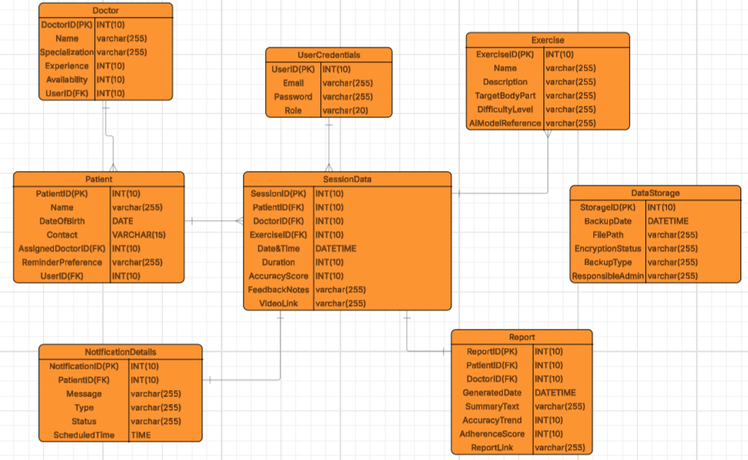

Mapping of Functional Requirements to Data Storage:
Functional Requirement | Mapped Entity | Purpose / Description
Create / Update / Delete accounts | UserCredentials, Doctor, Patient | Handles account management and role definition.
Authenticate users securely | UserCredentials | Passwords encrypted and authenticated via AES-256 and salted hash.
Send exercise reminders | Notification | Stores schedule, content, and delivery status.
Capture sessions via device camera | Session, DeviceData | Records session metadata and device linkages.
Store patient exercise history | Session | Tracks duration, feedback, and accuracy.
View weekly progress dashboard | Report, Session | Summarizes accuracy and adherence over time.
Alert for missed sessions | Notification | Triggers alerts for delayed or skipped exercises.
Generate visual progress reports | Report | Aggregates session and AI metrics.
Maintain secure login and MFA | UserCredentials | Enforces secure access for users.
Maintain historical exercise data | Session | Enables historical trend visualization.
Personalized exercise plans | Exercise | Doctor-defined therapy plans.
Manage backup and recovery | DataStorage | Logs all backup and restore activity.
Share reports with caregivers | Report | Generates downloadable or shared reports.

Proposed Prototypes:
📘 Overview:
The focus for this iteration is to:
- Finalize the system design and prototype descriptions.
- Define key modules, roles, and data flow for the upcoming development phase.
- Prepare detailed documentation that will guide implementation in the next semester.
The prototypes listed here represent the system components that will be developed and demonstrated during future iterations.
🧠 Project Description
- RehabEdge is an Android-based mobile application that assists patients in performing their prescribed physical-therapy exercises at home.
- The app uses AI-powered posture detection through the phone camera to evaluate movement accuracy and provide feedback.
- It helps patients stay consistent with their therapy schedule while giving doctors reliable progress data.
🎯 Objectives
- Provide doctors with secure progress insights through the stored data.
- Encourage exercise adherence through reminders and motivation.
- Ensure secure and continuous doctor-patient communication.
- Keep patient progress data safe and accessible for future therapy sessions.
Proposed Prototypes:
User Registration and Authentication
This module allows both doctors and patients to create and manage their accounts securely.
During registration, users choose their role (Doctor or Patient), which determines their dashboard access after login.
Passwords are stored in encrypted form to ensure data privacy.
Key Features:
- Common registration and login screen.
- Role selection during account creation.
- Encrypted password storage (no plain text).
- Secure login validation for both roles.
Doctor Dashboard
A personalized interface for doctors to monitor all assigned patients and their therapy adherence.
Key Features:
- View patient list with exercise completion details.
- Weekly progress charts and posture accuracy scores.
- Notifications when a patient misses multiple sessions.
- Option to set or adjust personalized exercise plans.
Patient Dashboard
The Patient Dashboard shows assigned exercises, feedback from the doctor, and overall performance trends.
It provides access to daily exercise reminders, progress reports, and posture analysis results.
Key Features:
- View daily assigned exercises and status.
- Access reminders and notifications.
- View AI-generated posture scores.
- Check feedback or progress shared by doctor.
Patient Reminder System
The Patient Reminder System helps patients stay consistent with their prescribed therapy schedule.
After the doctor assigns an exercise plan, the patient can set a preferred reminder time in the app. Once the time is saved, the system automatically sends notifications as reminders to perform the scheduled therapy exercises.
This ensures patients never miss their routines while allowing flexibility to choose times that fit their personal schedule.
Key Features:
- Patients manually set their preferred reminder times for exercises.
- The system automatically delivers notifications before the selected time.
- Patients can edit or delete reminders anytime.
- Helps patients maintain regular exercise habits and avoid missed sessions.
AI Posture Analysis Module
The app uses AI to detect and evaluate patient posture through the phone’s camera.
It provides instant accuracy scores and feedback for improvement.
Key Features:
- Real-time AI pose estimation.
- Accuracy scoring system.
- Saves posture results for doctor review.
Reporting and Analytics
Generates detailed performance summaries and trends for both doctors and patients.
Key Features:
- Weekly or monthly visual progress charts.
- Summary reports showing improvement over time.
- Exportable reports for tracking recovery.
Patient Appointment Booking
Allows patients to schedule follow-up or virtual consultations with their doctor.
Key Features:
- View available appointment slots.
- Request and confirm bookings.
- Appointment history tracking.
Progress Sharing
Patients can share progress reports with caregivers or family members to encourage motivation and support.
Key Features:
- Share reports securely via link or email.
- Control access and revoke sharing anytime.

Meeting Minutes:
Client Meeting 0:
Date: Wednesday, 08/27/2025, Time: 07:00 PM, Location: Zoom Meeting
1. Attendees
- Jhansi Akshara Sanagala
- Vaishnavi Sidduri
- Chaithanya Pilla
- Praneetha Reddy Lakkam
2. Meeting Agenda
- Discuss RehabEdge project goals and clarify scope (remote therapy + edge AI).
- Finalize features for MVP: posture detection, reminders, and doctor dashboard.
- Identify ML model options for edge-based pose estimation.
- Plan backend requirements (session logging, patient progress storage).
- Assign roles & responsibilities to each member.
- Prepare questions for client feedback before the demo.
- Decide on deliverables for the next meeting.
3.Questions Asked & By Whom
- Jhansi: What is the expected scope of the MVP — mobile only, or both mobile and web?
- Vaishnavi: Which AI/ML model should we use for posture detection at the edge?
- Chaithanya: Should backend handle only session logging, or also include analytics in phase one?
- Praneetha: Do we need to demonstrate reminder notifications in the prototype?
4.Answers Given & By Whom
- Jhansi: Suggested starting with MoveNet (TFLite) for pose estimation since it works well on edge devices.
- Vaishnavi: Confirmed that reminders are part of MVP for patient engagement.
- Chaithanya: Stated backend should focus first on session logging and exercise plan management, analytics can come later.
- Praneetha: Mentioned client feedback will clarify if sample datasets will be provided, otherwise team will create test videos.
5. Action Items (What to Show the Client Next)
For the next client meeting, the team will collect exercise data and prepare a basic demo of the RehabEdge system. This demo will include posture detection using the AI model along with simple reminders for patients. A basic dashboard with weekly progress will also be shown to give an overview of recovery trends.
6.Next Meeting
Date: Wednesday, 09/03/2025, Time: 07:00 PM, Location: Zoom Meeting
Client Meeting Minutes I:
Date: Wednesday, 09/03/2025,Time: 05:00 PM, Location: Zoom Meeting
Who Was Present
- Jhansi Akshara Sanagala - Frontend Developer (responsible for building the mobile/web interface for patients).
- Vaishnavi Sidduri -Project Manager & Backend Developer (responsible for managing tasks, client communication, and backend API development).
- Praneetha Reddy Lakkam - Tester & Documentation Lead (responsible for quality testing of the application and preparing project documentation).
- Chaithanya Reddy Pailla - Database Administrator (responsible for designing and maintaining the database for problem detection logs and patient records).
Meeting Agenda
- Review MVP Scope – Confirm decision to start with hand-related problems only, since full-body detection requires a large dataset and more time.
- Demonstrate AI Prototype – Present the initial AI module detecting simple hand issues such as restricted movement, improper angle, or abnormal tremors.
- Patient Reminders – Show how the mobile app reminds patients of their daily hand therapy tasks, and how additional alerts are triggered when repeated problems are detected.
- Backend Data Logging – Review how detected hand problems are categorized, logged, and stored in the backend database for doctor access.
- Doctor Dashboard Mockup – Display weekly summaries of patient hand problems (type, frequency, severity) in chart form, and how this helps doctors track recovery trends.
- Client Feedback Session – Gather input on MVP progress, validate whether starting with hand problems is acceptable, and discuss expectations for Phase 2 (expansion to other body parts and advanced analytics).
Specific Questions Asked (and Who Asked Them)
- Jhansi: “Is it acceptable to limit MVP to hand problem detection, or should we attempt partial whole-body detection as well?”
- Vaishnavi: “Should the reminders be designed specifically for hand therapy routines, or remain as general therapy notifications?”
- Chaithanya: “When storing data, should we capture raw movement details or only record detected problems and corrective actions?”
- Praneetha: “Should the doctor dashboard provide detailed breakdowns of each hand problem type, or is an overall weekly summary sufficient for now?”
Specific Answers Given (and Who Gave Them)
- Jhansi: Starting with hand problems is the right approach because it is practical, requires a smaller dataset, and makes MVP development manageable. Expansion to other body parts can be done in later phases.
- Vaishnavi: Reminders should be specific to hand therapy sessions. Patients should know exactly which exercise or hand therapy routine to follow when they receive notifications.
- Chaithanya: Only problem detections, severity, and frequency need to be logged. Storing raw video or movement data is not required due to privacy concerns.
- Praneetha: For MVP, a weekly summary with a breakdown of problem types (slouching hand, improper angle, stiffness, tremor, etc.) is sufficient. In later phases, more detailed per-session reports may be added.
Action Items – What to Show in the Next Client Meeting
In the next client meeting, the team will demonstrate the prototype detecting hand-related problems with real-time corrective feedback in the patient app. The backend will support both daily therapy reminders and problem-based alerts, while the database will log problem type, severity, and frequency. A doctor dashboard preview will show weekly progress trends using these logs. Testing results and updated documentation will also be presented to ensure qual
Next Client Meeting
- Wednesday (09/10/2025): Focus on Agenda #2 and #3 (MVP features + AI model choice).
- Friday (09/12/2025): Focus on Agenda #4 and #5 (backend plan + deliverables for demo).
Client Meeting II
Date: Friday, 09/12/2025, Time: 05:00 PM, Location: Zoom Meeting
Who Was Present
- Jhansi Akshara Sanagala - Frontend Developer (responsible for building the mobile/web interface for patients).
- Vaishnavi Sidduri -Project Manager & Backend Developer (responsible for managing tasks, client communication, and backend API development).
- Praneetha Reddy Lakkam - Tester & Documentation Lead (responsible for quality testing of the application and preparing project documentation).
- Chaithanya Reddy Pailla - Database Administrator (responsible for designing and maintaining the database for problem detection logs and patient records).
Meeting Agenda
- Finalize functional requirements for the RehabEdge system based on the project requirements document.
- Prioritize Mandatory (SHALL) vs Recommended (SHOULD) vs Optional (MAY) requirements for the MVP.
- Discuss which requirements will be implemented in Phase 1 (MVP) and which will be deferred to future phases.
- Backend considerations: logging, history storage, and security (encrypted credentials, no plain text passwords).
- Frontend/UI design alignment: confirm how patient and doctor dashboards will differ.
- Notifications and reminders: define frequency, triggers, and delivery mechanism.
- Security and compliance: confirm requirements for authentication, password storage, and role-based access.
Specific Questions Asked (and by whom)
- Jhansi: Should MVP include both patient and doctor account management or focus on patients only for phase one?
- Vaishnavi: Do we need to implement real-time corrective feedback (Recommended) in the first version, or should we limit MVP to posture detection only?
- Chaithanya: Is role-based access control (patient vs doctor) a strict requirement for MVP or can it be phased in later?
- Praneetha: Is offline functionality (Optional) important for MVP, or can it be postponed? Group (collective): What level of notifications are required — daily reminders only, or also escalation alerts for doctors when patients miss sessions?
Specific Answers Given (and by whom)
- Jhansi: Confirmed that both patient and doctor accounts will be included in MVP, though doctor accounts can start with limited features.
- Vaishnavi: Decided that real-time corrective feedback is important but not required for MVP; the MVP will only include posture detection.
- Chaithanya: Emphasized that role-based access control is necessary in MVP to ensure data is segmented properly between patients and doctors.
- Praneetha: Concluded that offline logging is not part of MVP but should be added to the roadmap for future phases.
- Group consensus: MVP will implement daily reminders and doctor notifications when patients miss multiple sessions since they are key to patient engagement.
Action Items
For the next client demo, the team will implement all mandatory requirements including secure patient and doctor accounts, encrypted authentication, daily reminders, posture detection via device camera, exercise history storage, and a doctor dashboard to track weekly progress. Role-based access control and notification alerts for missed sessions will also be part of the MVP to ensure usability and security. Recommended features like real-time corrective feedback and personalized plans will be documented for later phases, while optional features such as virtual appointments and offline logging are deferred to the roadmap. The immediate focus will be on delivering a stable and functional MVP that demonstrates the core therapy and monitoring capabilities.
Next Meeting
- Wednesday, 09/17/2025 at 07:00 PM (Zoom Meeting)
- Friday, 09/19/2025 at 07:00 PM (Zoom Meeting)

